**LM35 Module**

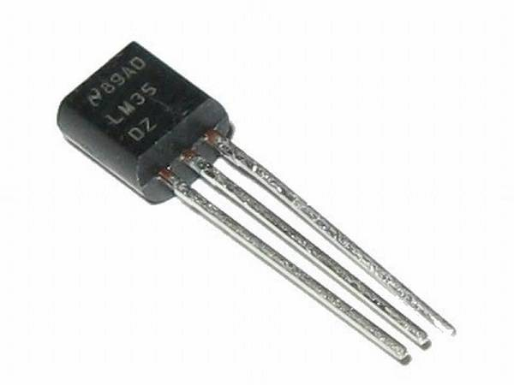

LM35 is a temperature sensor which can measure temperature in the range of -55°C to 150°C.It is a 3-terminal device that provides analog voltage proportional to the temperature. Higher the temperature, higher is the output voltage.

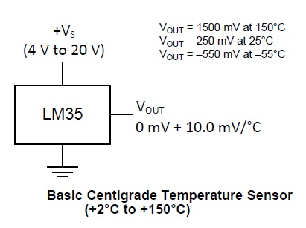

The voltage output of the LM35 increases 10mV per degree Celsius rise in temperature. LM35 can be operated from a 5V supply and the stand by current is less than 60uA.

LM35 is an analog temperature sensor. This means the output of LM35 is an analog signal. Microcontrollers don’t accept analog signals as their input directly. We need to convert this analog output signal to digital before we can feed it to a microcontroller’s input. For this purpose, we can use an ADC( Analog to Digital Converter. Arduino comes with inbuilt ADC. Arduino uno has an in built 10 bit ADC (6 channel). We can make use of this in built ADC of arduino to convert the analog output of LM35 to digital output. Since Arduino uno has a 6 channel inbuilt ADC, there are 6 analog input pins numbered from A0 to A5. Connect analog out of LM35 to any of these analog input pins of arduino.

**LM35 Sensor Module Features & Specifications**

* Operating Voltage: 5V DC
* 0-71 degree corresponds to 0 to 5000mV.
* Operating Current: 15mA
* LM358 based design
* Easy to use with Microcontrollers
* Small, cheap and easily available

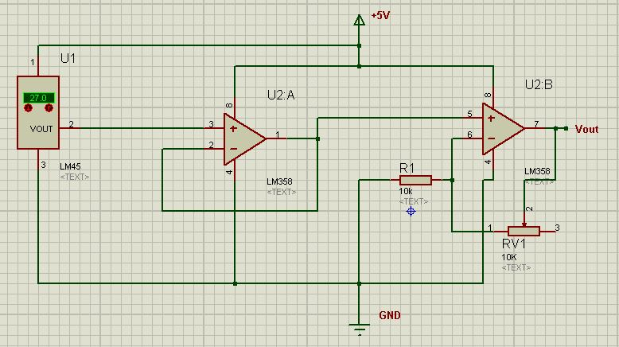

100K

LM35 sensor gives 10mV/degree Celcius. 1st opamp of LM358 is used as unity gain amplifier. 2nd opamp in LM358 is used as Non inverting amplifier.LM358 opamp can be used as single ended amplifier with max gain of 11.(1+Rf/R1) ,where R1 is 10k and Rf=100K max (Variable),therefore it is selected. 5000mV/712mV .gain 7 , therefore Rf=60K

Below is the Pin Description of the LM35 sensor Module:

|  |  |
| --- | --- |
| **Pin** | **Description** |
| Vcc | 5V power supply |
| GND | Ground |
| Aout | Analog output |

**Components Required**

* Arduino Uno (any Arduino board can be used)
* LM35 sensor module
* Jumper wires

**Circuit Diagram of Arduino with LM35 Sensor and LCD**

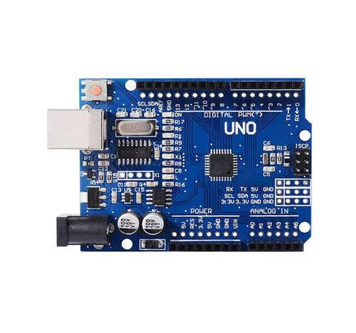

[Arduino](https://circuitdigest.com/arduino-projects) Uno is a open-source microcontroller board based on the ATmega328p microcontroller. It has 14 digital pins (out of which 6 pins can be used as PWM outputs), 6 analog inputs, on-board voltage regulators etc. Arduino Uno has 32KB of flash memory, 2KB of SRAM and 1KB of EEPROM. It operates at a clock frequency of 16MHz. Arduino Uno supports Serial, I2C, SPI communication for communicating with other devices. The table below shows the technical specification of Arduino Uno.

|  |  |
| --- | --- |
| Microcontroller | ATmega328p |
| Operating voltage | 5V |
| Input Voltage | 7-12V (recommended) |
| Digital I/O pins | 14 |
| Analog pins | 6 |
| Flash memory | 32KB |
| SRAM | 2KB |
| EEPROM | 1KB |
| Clock speed | 16MHz |

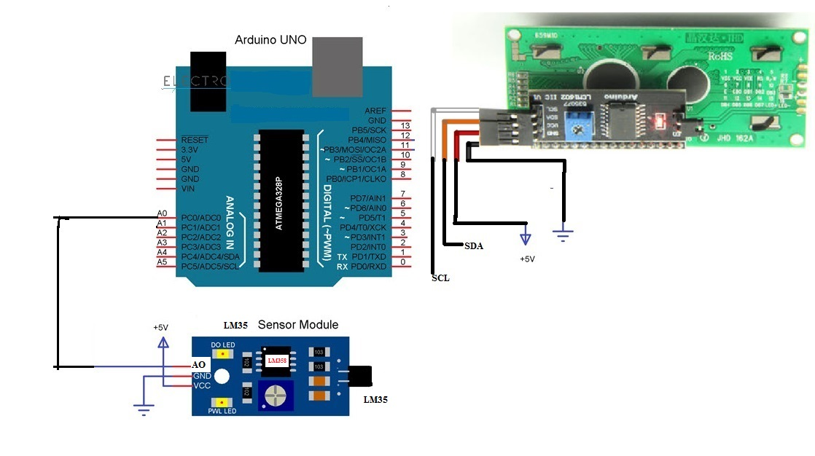

I2C LCD 16X2

**Working of LM35 Sensor with Arduino**

The **LM35 sensor module detects the temperature**. It gives analog output in the range of 0-71 degree equals to 0 to 5000mV. Arduino Uno through analog channel A0 converts this into digital value in the range of 0 to 1023.This is converted into analog value by scaling factor by program. If analog value formed is greater than the Setpoint ,alert message is sent to LCD.As higher temperature may cause fire.

LM35 sensor module has three pins (some may have four pins): VCC, GND and AO. Connect VCC and GND to +5V and GND of the power supply (can be connected to Arduino’s +5V). the AO (short for Analog Output) is connected to Analog I/O Pin A0 of Arduino.

Variable “*Temp_val*” is used for storing the Analog value read out from the LM35 Module. Based on this value we will detect the Temperature.

**#define LM35 A0**

**float Temp_Val ;**

**we are interfacing LM35 Module and also LCD(16X2)with Arduino. As LCD interfacing is explained ,we will concentrate on only LM35 Module interfacing.**

This line of code reads the analog output from LM35 sensor and stores it in the variable “*Temp_Val*”.

**Temp_Val = analogRead(LM35);**

From this we will get value in the range of 0 to 1023 bits. This bit value converted to Temperature in range of 0 to 71.22 using next expression.

**Temp_Val = (Temp_Val * 71.22) /(1024);**

This Temperature value is displayed on LCD. Also it is Compared with setpoint set in program.if Temperature goes above the setpoint, message is displayed on LCD.

**if (Temp_Val>50.00)**

**{**

**lcd.clear();//Clean the screen**

**lcd.setCursor(0, 0);**

**lcd.print("High Temperature");**

**lcd.setCursor(0, 1);**

**lcd.print(" Detected ");**

**}**

**Procedure**

1. Download and Install the Library **LiquidCrystal_I2c** and include **wire.h library**.
2. Write the code for the Arduino UNO using Arduino IDE.
3. Connect the components as the circuit attached.
4. Edit the code as need to change the text on LCD.
5. Upload the code on Arduino UNO.
6. Now check the text on LCD and make required corrections to fit text on LCD.

**Code**

*#include <Wire.h>*

*#include <LiquidCrystal_I2C.h>*

*LiquidCrystal_I2C lcd(0x27, 2, 1, 0, 4, 5, 6, 7, 3, POSITIVE); //*

*#define LM35 A0 //LM35 Module Analog out pin connected to A0 pin of Arduino*

*void setup()*

*{*

*//Initialisation*

*lcd.begin(16, 2);*

*lcd.clear();*

*lcd.backlight();//Power on the back light*

*}*

*void loop()*

*{*

*float Temp_Val;*

*Temp_Val = analogRead(LM35);*

*Temp_Val = (Temp_Val * 71.22) /(1024); //calibrate*

*lcd.clear();//Clean the screen*

*lcd.setCursor(0, 0);*

*lcd.print("TEMP.= ");*

*lcd.print(Temp_Val,2); //upto 2 decimal places*

*lcd.print(" \xDF"); //\x escape sequence*

*lcd.println("C ");*

*if (Temp_Val>50.00)*

*{*

*lcd.clear();//Clean the screen*

*lcd.setCursor(0, 0);*

*lcd.print("High Temperature");*

*lcd.setCursor(0, 1);*

*lcd.print(" Detected ");*

*}*

*delay(1000);*

*}*